Proposal for Website Design & Development
Submitted to: Dr. Dhardon Sharling, TenDrel Initiative
Submitted by: Tenzin Paljor, Norzin Consultancy
Date: 25 October 2025

1. Project Overview
The TenDrel Initiative seeks to establish a distinctive digital presence that reflects its mission of advancing moral imagination and planetary care. The proposed website will serve as the primary platform to share its vision, philosophy, and activities—anchored in the leadership of His Holiness the 14th Dalai Lama and the founder’s scholar-activist vision.
The project involves designing and developing a visually engaging, purpose-driven, and responsive website that captures TenDrel’s identity as a non-profit initiative at the intersection of mind, media, and moral futures.

2. Objectives
- Design and develop a modern, clean, and mobile-responsive website that reflects TenDrel’s values and aesthetic.
- Integrate the provided content for Home, About, and Strategic Pathways pages.
- Ensure a user experience that highlights the Initiative’s vision, mission, and founder’s story.
- Create intuitive navigation and visual consistency across all pages.
- Integrate high-quality visuals (from provided images/videos, with optional stock assets).
- Ensure the website is built under the .org domain to reflect TenDrel’s non-profit identity.

3. Scope of Work

A. Design & Branding
- Incorporate provided logo files, animated logo versions, and the Eternal Knot design.
- Create a website aesthetic aligned with the reference sites shared (Social Resonance Lab, Humanity United, All About Tibet).
- Develop a color palette and typography that reflect TenDrel’s contemplative yet modern identity.
- Include animated hero sections using provided videos and logo animation.

B. Website Structure & Pages
- Home Page – Animation hero section, vision/mission, founder overview, strategic pathways overview.
- About Page – Story of the TenDrel Initiative, logo philosophy, founder profile, and future team section.
- Strategic Pathways – Ten interlinked pathways with individual visuals/icons and descriptive section
- Contact/Support Page – Email/contact form, donation button, and social media links.

C. Domain & Hosting
- Purchase and setup of tendrelinitiative.org domain
- Integration with chosen hosting provider (recommendation can be provided)

4. Estimated Timeline
Phase | Duration
Discovery & Content Finalization | 1 week
Design Mockups | 1 week
Development & Integration | 2 weeks
Testing & Revisions | 2 weeks
Launch | 1 day
Total Estimated Duration | 6–8 weeks

5. Estimated Cost
Task / Service | Est. Cost (USD)
Website Design & Development | $500
Domain Purchase (tendrelinitiative.org for 3 years) & Setup | $80
SEO & Optimization | Included
Testing, QA & Launch | Included
Estimated Total | $580 USD

6. Payment Terms
- 50% advance upon project initiation
- 50% upon final delivery and launch

7. Next Steps
Once approved, we will initiate a brief kickoff meeting to confirm design direction, hosting preferences, and timeline. Upon domain purchase, the project will proceed immediately into the design phase.

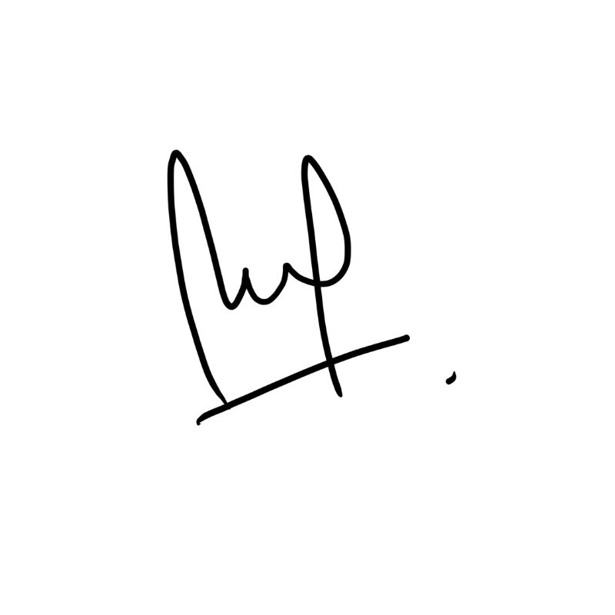
Best regards,

Tenzin Paljor
Email Address: tenzin.paljor@norzinconsultancy.com
Contact No. +91-9958662292

